ABOUT THE PATIENT Kumlien Chiropractic, LLC, 204 ½ 2nd Ave. East, Osceola, WI, 54020
Name ______________________________________________ Today’s Date____________ Birthdate ____________ Age________
Address ____________________________________________ City __________________________ State ______ Zip ___________
Home Phone ____________________ Cell Phone ____________________ Work Phone ____________________Gender  M  F
Significant Other’s Name ______________________________ Kid’s Names and Ages _____________________________________
Your Employer ______________________________________ Type of Work ____________________________________________
e-Mail Address __________________________________________________ Have you been to a chiropractor before? □ No □ Yes
Emergency Contact ______________________________________________ ph # _______________________________________
Name of Medical Doctor(s)______________________________________________________________________________________
- I authorize the doctor or his staff to render care as deemed appropriate for me and / or my child.
- I authorize Kumlien Chiropractic, LLC to release and / or request records to or from other providers as may be necessary.
- I understand I am responsible for all bills incurred in this office.
- I authorize assignment of my insurance benefits (if applicable) directly to the provider.
- Person responsible for this account if other than the patient?______________________________
- I understand that after any initial promotional services all care is rendered at usual and customary fees.
- For my balance my preferred payment method is:  Cash  Check  Credit Card  Car/Work Ins.

________________________________________________________________________ _____________________________
Patient / Parent Signature (This represents a long term authorization for all occasions of service) Date

REASON FOR SEEKING CARE
PRESENT COMPLAINTS
1. ______________________________________________________ How long has this been an issue? ______________________
Is it:  Dull  Sharp  Ache  Numb / Tingle  Stabbing  Constant  Occasional  Staying the same  Getting worse
❑ Mild  Moderate  Severe  Worse in the morning  Worse in evening  Pain radiates to__________________________
2. ______________________________________________________ How long has this been an issue? ______________________
Is it:  Dull  Sharp  Ache  Numb / Tingle  Stabbing  Constant  Occasional  Staying the same  Getting worse
❑ Mild  Moderate  Severe  Worse in the morning  Worse in evening  Pain radiates to__________________________
3. ______________________________________________________ How long has this been an issue? ______________________
Is it:  Dull  Sharp  Ache  Numb / Tingle  Stabbing  Constant  Occasional  Staying the same  Getting worse
❑ Mild  Moderate  Severe  Worse in the morning  Worse in evening  Pain radiates to__________________________
4. ______________________________________________________ How long has this been an issue? ______________________
Is it:  Dull  Sharp  Ache  Numb / Tingle  Stabbing  Constant  Occasional  Staying the same  Getting worse
❑ Mild  Moderate  Severe  Worse in the morning  Worse in evening  Pain radiates to__________________________

5. Does your condition affect:  Sleep  Work  Daily Routine  Sitting  Driving
_______________________________________________________________________
6. What makes it better?___________________________________________________
7. What makes it worse? __________________________________________________
8. What Doctor’s have you seen for this?______________________________________
_______________________________________________________________________
9. Type of treatment:______________________________________________________
10. Results: ____________________________________________________________
NOTES: _______________________________________________________________
_______________________________________________________________________
_________________________________________________

PAST HISTORY
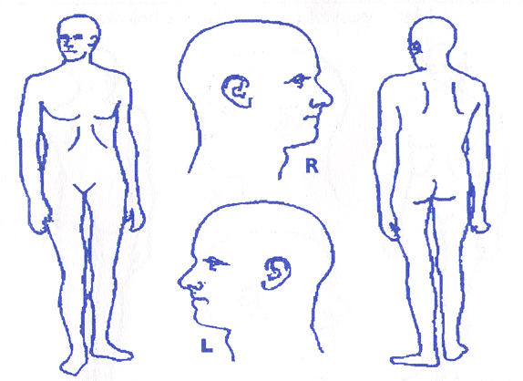
Please mark All areas of concern.
Page 1 of 2

Are you pregnant?
❑ Yes  No

